
OUTDOOR ACTIVITIES MANUAL
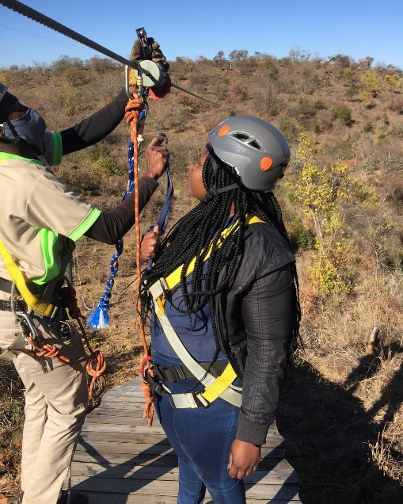
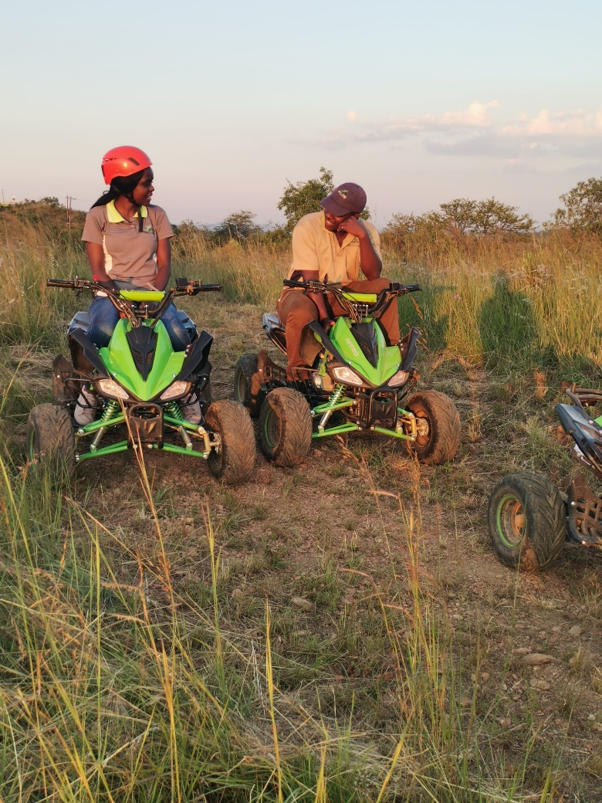

Table of Contents
OVERVIEW………………………………………… ……………………………………………………………………….5
1.0 SECTION A - STAFF ETIQUETTE ……………………………………………………………………………6
1.1 STAFF RULES AND REGULATION 6
1.2 ACTIVITIES ETIQUETTE 7
1.3 GROOMING & HYGIENE OF STAFF 8
1.4 INTERPERSONAL SKILLS 9
1.5 PERSONAL SKILLS AND TRAITS 9
1.6 GENERAL ROLE, RESPONSIBILITIES OF STAFF ACTIVITIES DEPARTMENT 9
1.6.1 Operator Supervisor 10
1.6.2 Course Operator 10
1.6.3 Zipline Operator 11
1.6.4 Zipline Harnessing Operator 12
1.6.5 Zipline Loading and Unloading Operator 12
1.6.6 Quad Bike Instructor 13
2.0 SECTION B - PRE-TRAINING ……………………………………………………………………………….14
2.1 OPERATOR 14
2.2 TRAINING 15
3.0 SECTION C- GENERAL PROCEDURES…………………………………………………………….......16
3.1 DAILY PRE-USE INSPECTION BEFORE OPENING THE COURSE 16
3.2 END OF DAY PROCEDURE 16
3.3 EQUIPMENT STORAGE PROCEDURES 17
3.4 EQUIPMENT CLEANING PROCEDURES 17
3.5 RULES SIGN PROCEDURES 17
3.6 HANDLING PARTICIPANT COMPLAINTS PROCEDURE 18
3.7 HANDLING PARTICIPANTS BEHAVIOUR PROCEDURE 19
3.8 SAFETY REPORTS PROCEDURE 19
4.0 SECTION E- ACTIVITIES - ZIPLINE ……………………………………………………………………….20
4.1 PARTICIPANT RULES AND RESPONSIBILITIES 20
4.2 ASSISTING PARTICIPANTS 21
4.3 PHYSICAL LIMITATION 22
4.4 MEDICAL LIMITATION 22
4.5 WEATHER RESTRICTIONS 22
4.6 RESCUE AND EMERGENCY PROCEDURES 24
4.7 INSPECTING SAFETY EQUIPMENT 25
5.0 SECTION E - QUAD BIKE ……………………………………………………………………………………29
5.1 RIDER RULES AND RESPONSIBILITIES 29
5.2 PHYSICAL LIMITATION 30
5.3 MEDICAL LIMITATION 31
5.4 WEATHER RESTRICTIONS 31
5.5 INSPECTING SAFETY EQUIPMENT 31
5.6 QUAD BIKE MAINTENANCE 32
5.7 WORK PROCEDURE 33
5.8 END OF DAY OPERATION 34
6.0 SECTION F - MOUNTAINEERING ……………………………………………………………………….35
6.1 RULES AND RESPONSIBILITIES 35
6.2 PHYSICAL LIMITATION 36
6.3 MEDICAL LIMITATION 36
6.4 WEATHER RESTRICTIONS 36
7.0 SECTION G - PUTT PUTT (MINI GOLF)…………………………………………………………......37
7.1 RULES AND RESPONSIBILITIES 37
8.0 SECTION H – BIKING…………………………………………………………………………………...38
8.1 RIDER RULES AND RESPONSIBILITIES 38
8.2 PHYSICAL LIMITATION 39
8.3 MEDICAL LIMITATION 40
8.4 WEATHER RESTRICTIONS 40
8.5 INSPECTING SAFETY EQUIPMENT 40
8.6 BIKE MAINTENANCE 40
8.7 WORK PROCEDURE 41
8.8 END OF DAY OPERATION 42
9.0 SECTION I– CO-ORDINATION WITH OTHER DEPARTMENTS ………………………………43
9.1 ACTIVITIES CO-ORDINATION WITH FRONT-OFFICE 43
9.2 ACTIVITIES CO-ORDINATION WITH HUMAN RESOURCE 43
9.3 ACTIVITIES CO-ORDINATION WITH PURCHASE& STORES 44
9.4 ACTIVITIES CO-ORDINATION WITH SECURITY 44
9.5 ACTIVITIES CO-ORDINATION WITH MAINTENANCE 44
9.6 ACTIVITIES CO-ORDINATION WITH SALES AND MARKETING 44
9.7 ACTIVITIES CO-ORDINATION WITH FINANCE DEPARTMENT 44
ANNEXES ………………………………………………………………………………………………………………….45

OVERVIEW
Blue Hills makes you appreciate nature, it’s beauty, splendor and wonder and in turn caring more about protecting it.

The Activity Department consists of Zipline, Mountaineering, Quad bike, Putt Putt and Biking. Blue Hills Camp makes sure that the outdoor adventures are safe and reliable so that the guests can focus on having fun, unwinding and rediscovering how simple life can be by disconnecting from the hustle and bustle of city life that stress you. Blue Hills Camp .

The Zipline facility brings you zip lining as it should be, really long, breathtakingly high, extremely fast on 2 exciting slides that leaves you wanting more and more. Our zip lining takes our participant through an unforgettable and adrenaline filled journey that offers the most beautiful nature scenery imaginable.

Quad Bike and Biking are designed especially for off-road driving experiences which is guaranteed to leave you thrilled to the bones, a quad bike is a four-wheeled beast that will help you bounce across the terrain.

1.0 SECTION A - STAFF ETIQUETTE
Etiquette refers to the generally accepted standards of good behaviour expected of staff in the Activities Department. Without etiquette, it would be difficult for the campsite to thrive in the competitive hospitality industry, hence treating people well is of paramount importance.

STAFF RULES AND REGULATION
- Arrive On time, inspired and motivated.
- Neatly dress up in the prescribed housekeeping attire and maintain high grooming standards.
- Smile naturally on stage and backstage.
- Be proactive and motivate each other.
- There is no mine, Activitiesdepartment everything is ours.
- Even if smoking is not good for you, you are only allowed to smoke in the designated staff area (As per campsite policy)
- After smoking, please consider our guests and colleagues, wash your hands & take a mouthwash or mint.
- Breaks are important but don’t take extensive ones.
- Always communicate your position with your team mates.
- Keep your eyes open, observe and check our environment permanently.
- Report any irregularities.
- It’s your responsibility to keep the campsite clean, maintained and stylish.
- Every guest is treated as a VIP.
- Never say I don’t know or/and it’s not my job, always offer an alternative.
- Chewing doesn’t look good on you.
- Stand up straight, don’t lean on the wall.
- Keep your mobile phone on silent mode and do not speak on your mobile in the guest areas.
- Don’t hide your mistake, instead learn from it.
- Do not disclose guest details e.g profiles, outside the campsite.
- Never say out the guest room number, instead point out the room number displayed on the key card
- All employees shall log in and out of duty every day at the start and finish of work in the log sheet
- All employees should rep
- ort to the Supervisor if they are not fit for work

1.2 ACTIVITIES ETIQUETTE
Staff should fervently follow the following instructions:
- Always greet guest and colleagues with a smile and maintain a friendly and pleasant expression.
- Stand upright, do not fold your arms in front of the guest.
- Give way to guests you meet on a narrow path
- Keep your hands out of your pockets.
- Do not loiter around the campsite aimlessly
- Do not play with your hair and jewellery when you are at the front of the house area.
- If you have long hair, keep your hair neatly tided to the back
- Ensure a positive body language at all times.
- Always be tactful and courteous, never argue with guests.
- Be humoured and even-tempered, do not become over friendly with guests.
- Always be attentive when speaking to guest and look at a guest when addressing him/ her. Try to ask the right questions to identify the needs of the guests.
- Talk clearly and maintain a good tone of voice at all times.
- Do not criticize one guest to another.
- Do not refer guest as “He/She to They“in their presence.
- Never weary the guest with your troubles.
- Never discuss religion or politics with guests.
- Be specific in your explanations, in-case of any doubt then consult your supervisor and promptly get back to the guest.
- Always give the guest a warm and friendly welcome, “Good morning Mr /Mrs, how may I help you today”.
- Make the guest feel comfortable and safe.
- Refer to the guest twice by the correct title and name once known.
- Identify the guest’s needs and try to provide anticipatory service.
- Always observe what is happening around you and be ready to assist the guest when needed.
- Show guests a sympathetic interest.
- Take your time when attending to a guest and do not rush them (give a guest undivided attention).
- Appear neat and tidy but never severe or harsh or strict to the guests.
- Always try to maintain eye contact with the guests.
- For questions related to available facilities and services redirect the guest to front office
Dialogues
- Can I ask the Front Office to contact you for the details on the activities and several services available today?

Inform the Front Office about the questions asked by the guest.
- Know who is who in the camp organization.
- Treat every client as a VIP guest
- Have a clear understanding of the layout of the campsite
- Be aware of any special promotions going on at the campsite
- Activities team should have a good knowledge of the Activities.
- Activities team should conduct themselves with a friendly, cooperative attitude.

1.3 GROOMING & HYGIENE OF STAFF
- All Activities staff have to present themselves in a neat and tidy manner putting on a complete regalia
- All employees should wear the campsite uniform on duty.
- Brush your teeth regularly
- Cover your head with a headgear always
- Do not chew gum, tobacco especially in the food production area
- Wash hands regularly
- Gargle after smoking and have a breath freshener.
1.3.1 All uniforms should be:
- Clean at the start of each day / throughout the day
- Worn in the correct manner
- Shoes worn should be suitable for the role
- A staff member must wear their name tag at all times

1.3.2 Hair
- Short hair should be kept short and neatly cut for men and women
- Long hair for ladies should be kept tight or pulled back
- Ensure that the natural hair colour is maintained
- Men to have well-trimmed facial hair or to be clean shaven.

1.3.3 Nails
- Should be kept short and well-trimmed
- No bright nail polish
- Cleaned on a regular basis.
- No artificial nails
1.3.4 Jewellery
- One dress ring or wedding ring
- Suitable watches
- Minimise jewellery such as bracelets, earrings, nose rings or necklaces.
- No necklaces, bracelets, or dangling jewellery are permitted.
1.3.6 Make up
- Ensure that you do not wear excessive make up or have any visible tattoos.

    - Odour
- Do not wear disproportionate perfumes
- Staff should use deodorant on a regular basis.

    - Personal hygiene
- Bathe or shower before work
- Teeth must be brushed regularly
- Hands and face must be washed and kept clean
- Mobile phones to be on silent

1.4 INTERPERSONAL SKILLS
For serving the guest and working for cleanliness, the Activities staff must:
- Possess right attitude.
- Have good listening skills to avoid any miscommunication
- Be a good team player.

1.5 PERSONAL SKILLS AND TRAITS
- The Activities staff must:
- Be able to retain and pursue the demand of the guest until it is fulfilled.
- Be sincere and physically fit
- Respect each campsite guest they are dealing with. They must conduct themselves confidently and courteously.
- Have high integrity.

1.6 GENERAL ROLE, RESPONSIBILITIES OF STAFF ACTIVITIES DEPARTMENT
Activities Department should:-
- Able to provide a warm welcome and fond farewell to the guests.
- Greet guests according to the standards to ensure superior service.
- Anticipate guest needs, ascertain satisfaction, and respond urgently and appropriately to guest concerns and requests.
- Possess good knowledge of a different kinds of Activities offered at the camp site
- Make sure all assigned duties prior to service are completed.
- Handle all guest complaints in a professional manner.
- Report any theft or damages to the supervisor
- Report to the supervisor before completion of the shift.
- Compile your dockets and reconcile with the cashier
- Close the shift after clearing all the activities are done
- Able to report for duty punctually, wearing a correct and clean uniform and name badge at all times.
- Able to have a complete understanding of the Activities operating policies and procedures.
- Must participate in staff training and briefings.
- Able to maintain a good teamwork relationship with colleagues.
- Able to maintain a high standard of personal appearance and hygiene at all times.
- Able to carry out other reasonable duties and responsibilities as assigned.

1.6.1 Operator Supervisor
Duties and Responsibilities:

Operations Supervisor is the person/s or persons in charge of the campsite outdoor Activities

Demonstrate proper judgment and possess good leadership skills.
- Possess excellent communication skills both verbal and written skills.
- Agree to uphold all BHC policies and procedures.
- It is required that all operators must practice the emergency take down at least once a month.
- 100% attendance of training session.

The Operations supervisor is required to provide Check Lists for each and every activity

1.6.2 Course Operator
Duties and Responsibilities:
- Possess excellent communication skills both verbal and written skills.
- Agree to uphold all BHC policies and procedures.
- Tasked with the day-to-day operation of a course, which includes all pre-use inspections of the course and safety equipment, properly outfits participants, constantly monitors activity on the course and maintains a low risk environment.
- Operators must be willing to become familiar with all aspects of operating campsite equipment.
- An operator, must attend training conducted by a certified operator trainer as well as pass written and practical testing.
- Operators makes sure that no one is allowed on the course without the proper safety equipment. If someone is seen on the course without the proper equipment notify the Operations management immediately.
- Responsible for all opening and closing procedures including the daily inspection.
- Responsible for outfitting all participants in the correct safety equipment and performing all pre-flight checks.
- Operator(s) must constantly monitor all participant activity, enforce all safety rules and stop any behavior before it becomes unsafe.
- All necessary paperwork must be filled out completely before opening and after closing the course. This includes the course checklist and safety report if needed.
- It is required that all operators must practice the emergency take down at least once a month.
- 100% attendance of all training session scheduled by management.
- The use of cell phones for calling or texting and use of any devices such as MP3 players or handheld video games is strictly prohibited. This could result in termination of your job.

1.6.3 Zipline Operator
Duties and Responsibilities:
- Operator(s) must place themselves in a position to communicate with co-workers and participants at all times.
- Operators must wear a whistle at all times in order to gain the attention of participants or sound the alarm in the instance of an emergency. It is BHC policy that all operators are provided with a whistle.
- All necessary paperwork must be filled out completely before opening and after closing the course. This includes the course checklist and safety report if needed.
- The use of cell phones for calling or texting and use of any devices such as MP3 players or handheld video games is strictly prohibited. This could result in termination of your job.
- Possess excellent communication skills both verbal and written communication skills.
- Agree to uphold all BHC policies and procedures.
- It is required that all operators must practice the emergency take down at least once a month.
- 100% attendance of training session scheduled by management.
- Capabilities to bend, stoop, climb and stand for long periods of time.
- Ability to insert and remove the puck of the slider assembly into and out of the overhead track.
- Must be able to communicate with staff and participants clearly.
- Ability to understand and use a harness properly.
- Must be able to outfit all participants by choosing the correct size harness and make the needed adjustments to fit their body.
- Demonstrate complete understanding of harness components.
- Knowledge and ability to inspect all safety equipment and understand when something is unsafe.
- Follow all participant rules and perform their duties without restrictions for the safety of all parties involved.
- Comfortable being in close proximity to people of all ages and genders.
- Properly attach the sling line to a participant’s harness, make correct adjustments in the length of the sling line and consistently inspect the slider assembly for any damage or deformation before inserting it into the overhead track.
- Must be willing to work at heights of 15’ (4.6m) or more for extended periods of time.
- Use skill to assess the difference between a medical emergency and non-emergency incident for purposes of the emergency take down procedures.
- Monitor all participants on the course and immediately stop any unsafe behavior.
- Operator must constantly monitor behavior on the course and help participants that need assistance by acting in a timely manner especially to assist scared or stuck participants.
- Express appropriate behavior towards customers and guests.
- Determine if a participant needs medical attention and will have to be lowered off of the course using the emergency take down (ETD) procedures.
- It is the responsibility of the operator on the course closest to the participant in need, to make the decision to initiate the ETD and alert the other operators.

1.6.4 Zipline Harnessing Operator
Duties and Responsibilities:
- Possess excellent communication skills both verbal and written skills.
- Agree to uphold all BHC policies and procedures.
- It is required that all operators must practice the emergency take down at least once a month.
- 100% attendance of training session scheduled by management.
- While harnessing participants operators must explain the rules for the activity.
- Operators must choose the proper size harness for the participant and ensure that the harness fits correctly before allowing them on the course.
- While harnessing participants, operators must assess the harness for damage.
- Only operators or course assistants are allowed to harness participants.
- Operators should never allow any one who is not trained to harness or de-harness a participant.
- Operators must pull out and down on the shoulder straps to check if the harness is tightened properly before the participant is permitted to go on the course.

1.6.5 Zipline Loading and Unloading Operator
Duties and Responsibilities:
- The loading and unloading operator is stationed at the entrance/exit to the course.
- The loading operator is responsible for connecting the participant's harness to the sling line and conducting the pre-flight checks.
- Only a certified operator is allowed to attach/detach the sling line to a participant's harness
- Operators may not at any time leave the entrance/exit unattended while the course is in operation.

1.6.6 Quad Bike Instructor
Duties and Responsibilities:
- Possess excellent communication skills both verbal and written skills.
- Agree to uphold all BHC policies and procedures.
- Locate and ensure you are familiar with all machine operations, controls and warnings.
- Check fuel, tyres, guards, drive line and brakes as recommended by the manufacturer.
- Quad bike will only be used if it has passed the check list as per the operator.
- After use remove any foreign material from in and around engine parts.
- Ensure no person or animal is endangered when operating equipment.
- Advise your supervisor of any mechanical problems and do not ride a quad bike that is not in good condition.
- Check for damage and report if found.

2.0 SECTION B - PRE-TRAINING

All operators need to fully understand this section prior to training. If they do not feel confident in becoming an operator or do not fit all of the requirements please notify your supervisor.

2.1 OPERATOR
An operator is tasked with the day-to-day operation of a course, which includes pre-use inspections of the course and safety equipment, to properly outfit participants, to monitor activity on the course, and to maintain safety. An individual must attend training conducted by a certified operator trainer as well as pass written and practical testing.

2.1.1 Operator Requirements
- 100% attendance of training session.
- Capabilities to bend, stoop, climb and stand for long periods of time.
- Ability to insert and remove the puck of the slider assembly into and out of the overhead track.
- Must be able to communicate with staff and participants clearly.
- Successful completion of written and practical tests.
- Ability to understand and use a harness properly.
- Must be able to outfit all participants by choosing the correct size harness and make the needed adjustments to fit their body.
- Demonstrate complete understanding of harness components.
- Knowledge and ability to inspect all safety equipment and understand when something is unsafe.
- Follow all participant rules and perform their duties without restrictions for the safety of all parties involved.
- Comfortable being in close proximity to people of all ages and genders.
- Properly attach the sling line to a participant’s harness, make correct adjustments in the length of the sling line and consistently inspect the slider assembly for any damage or deformation before inserting it into the overhead track.
- Monitor all participants on and off the course.
- Must be willing to work at heights of 15’ (4.6m) or more for extended periods of time.
- Use competence to assess the difference between a medical emergency and non-emergency incident for purposes of the emergency take down procedures.
- Monitor all participants on the course and immediately stop any unsafe behavior.
- Capability and understanding to assist scared participants.
- Possess excellent communication skills.
- Express appropriate behavior towards customers and guests

2.2 TRAINING
BHC aims to deliver the most comprehensive skill set training to each operator on the skills necessary for safe course operation.
Operators should demonstrate competence in skills, knowledge of all policies and procedures and pass written and practical tests as per the campsite policy and procedures upon finishing training an individual will be awarded an operator certificate. A certificate may be revoked for the following reasons:
- If BHC policy or procedure is disregarded.
- If the course is operated in a careless or reckless manner.
- If the operator operates the course unprofessionally.
- Failure to follow paperwork procedures.

All decisions made to revoke a certificate will be at the sole discretion of BHC.

At training, participants are expected to arrive fully prepared for an all-day training.
Participants must be in comfortable clothes and secure footwear. No skirts, dresses, flip flops or open-heeled shoes.

Trainees must participate 100% ALL session scheduled by management.

3.0 SECTION C- GENERAL PROCEDURES

The Activities department is responsible in the following areas:
- Rope courses including Zipline
- Quad Bike
- Mountaineering
- Putt Put (Mini golf course)

3.1 DAILY PRE-USE INSPECTION BEFORE OPENING THE COURSE

- All components of the activities must be inspected before the course opens each day. The entire course must be cycled by an operator as part of this inspection in which every element is crossed and are climbed.
- The operator/s shall daily inspect the equipment before participants are allowed on the course.
- The daily inspection is a visual and tactile inspection of the course structure and all safety equipment. Use the daily checklist to complete the daily inspection.
- The daily inspection must be recorded on the daily checklist provided or approved by the campsite, the checklist must be filled out completely each day and kept on file on campsite.
- Any element that the operator deems unsafe for use must be closed off and documented and notify the Supervisor / Management.
- Before opening to the public there must be the suitable number of operators present at the course and equipped in the suitable safety equipment.
- All barriers to the course should be removed and queue lines set up
- All elements must be crossed and inspected along the way. There should be nothing out of
the ordinary. Anything found should be noted on the checklist and a manager or supervisor should be notified immediately. Any elements that fail must be blocked off until they can be replaced.

END OF DAY PROCEDURE
- When closing the course, operators must ensure that everyone is off the course and all gear is stored properly.
- If harnesses and/or sling lines become wet they must be stored to dry, out of direct sunlight.
- If gear was soiled with a biohazard, the proper cleaning procedures must be taken before leaving the course.
- Ensure that fences and barriers are locked to prevent reasonable efforts to gain access to the course without supervision.
- Ensure all necessary paperwork have been completed and sent to the supervisor / management in the event of any injuries that occurred throughout the day,
- Ensure that all maintenance logs have been completed and signed

3.3 EQUIPMENT STORAGE PROCEDURES
- Store in a cool, dry area away from any damaging chemicals such as acids, petroleum based products, alkaline or bleach.
- Do not expose to direct sunlight for long periods of time.
- Only store when dry.
- Do not drag equipment across rough surfaces.
- Do not store in temperatures exceeding 110º F (43ºC).
- Store separately harness and sling untied

3.4 EQUIPMENT CLEANING PROCEDURES

- Fill a clean tub with warm water.
- Immerse the harness, sling line or rescue rope in the cleaning solution and scrub the soiled parts of the webbing using a soft cloth or another piece of webbing.
- Do NOT use scrubbing tools such as wire brushes as this can damage the webbing.
- Do not soak the equipment for longer than 10 minutes.
- Thoroughly rinse the safety equipment in fresh water.
- Hang equipment up to dry out of direct sunlight.

3.5 RULES SIGN PROCEDURES
- All participants have a duty to read and acknowledge the rules.
- A participant rules sign is provided with each course and it is mandatory that this sign is posted near the course.
- Rules signs must be accessible to participants and presented in such a way that makes viewing them easy. These signs should be posted near the entrance or loading area of the course.
- Participants may not ride with food, beverages, glass, or any other loose items.
- Participants must not be allowed to sit on or lean over the gates
- Participants may not move past the gates or safety line until it is their turn to ride.
- Participants should be able to sit up properly in the seat and brace themselves adequately against the forces created by the ride.

3.6 HANDLING PARTICIPANT COMPLAINTS PROCEDURE
3.6.1 Understand few common reasons for ‘Why Guest complaints?’:
- Unfriendly staff or lack of a warm greeting.
- Lack of courtesy by staff
- Unhelpful attitudes of staff.
- Overly friendly staff.
- Not giving enough responses to customer requests.
- Non responsive attitude of management for complaints etc.
- Queue too long
- Operator attending someone who came last
3.6.2 Handling Guest complaints
- Calmly and patiently listen and empathize.
- Any complaint received is to be dealt with by the appropriate Department Head and reported to the Manager.
- It is imperative to ensure prompt, efficient and courteous action to any complaint received.
- Initiate the required service recovery steps immediately.
- The correct approach to the customer is the key to success. The staff shall not be servile but anticipate the guests.
- A careful watch shall be kept on the participates at all times during the activities without being obvious.
- Care shall always be taken when dealing with a difficult customer.
- Never argue with a participant as it only aggravates the situation but refer all complaints to the designated superior.
- All written complaints (online or by letter) must be investigated and answered promptly.
- Try to rectify all guest-related problems as soon as they are brought forward. The more time that elapses before a solution is reached, the more complex the situation becomes.

3.7 HANDLING PARTICIPANTS BEHAVIOUR PROCEDURE
- Participants shall comply with all warnings and instructions provided by the Operator.
- Participants shall refrain from behaving in any manner that may cause or contribute to the injury of themselves or others, including and not limited to the following:
    - Exceeding the limits of the passenger’s ability.
    - Interfering with safe operation of the ride.
    - Disengaging any safety devices provided.
    - Disconnecting or disabling any safety or restraint device.
    - Throwing, dropping, or expelling any object from the ride during operation.
    - Attempting to board the ride when they or their parent/guardian have reasonable doubts concerning their safety or ability to use the ride.
    - Being under the influence of alcohol or any controlled substance that affect his/her ability to safely use the ride / activity.
    - Disregarding any and all posted or oral instructions of the ride operator.

3.8 SAFETY REPORTS PROCEDURE
Safety reports must be filled out for the following reasons:
- Any injury or illness that required immediate operator attention and/or first aid. (e.g scraped shin, cut hand, heat exhaustion, diabetic coma, large bruise.)
- If hospitalization is required, recommended or will be needed at a later date. (e.g Dislocated shoulder, broken bone, deep laceration.)
- Near misses or incidents that could have resulted in serious injury/death. (e.g participant takes off harness while on ropes course, participant is on course with no safety equipment, critical element failure, dropped object.)
- Extreme fear which leads to an emergency take down (ETD).
Safety reports do not need to be filled out for the following reasons:
- Participant broke a rule and was NOT subsequently injured. (Examples: two people walking on an element at a time, participant was swinging in harness.)
- Minor injuries as defined by the course manager. (Examples: bloody nose, reopened small wound, minor bruise.)
- Participant was scared.

All safety reports must be sent to Management within 24hrs of the incident.

4.0 SECTION E- ACTIVITIES - ZIPLINE

The following section contains instructions for participants on Zipline or any rope courses, assisting participants, physical and medical limitations, participant behavior, weather restrictions and safety equipment

4.1 PARTICIPANT RULES AND RESPONSIBILITIES
- The Zipliner should be above 18 years old. All children under 16 must be accompanied by a paid parent/ guardian or paid tour guide who is 18 years and above or paid guide during the entire tour experience at the same time as the child and they must also sign this liability waiver as the Undersigned of the minor child during the orientation process (children 16-17 may participate alone, but must have a parent or guardian 18 years or older present at the orientation to sign this liability waiver as their Undersigned) able to comprehend and follow all safety instructions.
- Participant weigh between 27kgs and 125kgs.
- The participant must fit safely into a harness to be allowed to ride.
- No loose jewellery or personal items are permitted.
- No food & beverage is permitted on the tour;
- Hair must be secured so that it cannot come in contact with zip line apparatus
- Additional restrictions may apply based on weather conditions.
- BHC reserves the right to disqualify any participant based on tour operator judgment.
- Participants must safely fit in the harness.
- Participants must have secure shoes. No bare feet, flip-flops or open heel shoes.
- Participants must follow all operator instructions, posted rule signs and stickers.
- Only 1 participant at a time except if child is being assisted by responsible operator .
- The redundant sling line should stay in front of and between shoulders at all times. Do not allow redundant sling line to go under arm.
- Participate should be in good health to participate.
- If the participate suspect that their health could be at risk for any reason or could aggravate a pre-existing condition of any kind, the participate should not participate.
- Participants must climb, bend, stoop and walk up and down stairs, etc. Those who are not able to easily perform these activities should not attempt a zipline tour.
- Pregnant women should refrain from participating.
- In the case of an accident, a manager must be notified and the operator, manager
- In the event of any accident participant may be asked to fill out a safety report. It is important to report accidents and fill out a safety report. This can help determine the cause of the accident and the actions to prevent other participants from injuring themselves. If the accident was caused by an operator or course error this must be addressed immediately. If the accident was caused by the behavior or actions of the participant, filling out the proper paperwork can help with preventing a further claim by the participant.
- Participants Belongings
- Participants must not carry personal belongings on the ride.
- Participant will be given use of locked storage for keys, phone, camera, etc. or have the participant leave items with a friend or in the car .
- Operators are not responsible for items left unattended.
- Participants Foot wear / Clothing
- Participants must have secure footwear; no open heeled shoes, no flip-flops and no bare feet.
- Participants should also be dry and in clothing that covers their shoulders and thighs. This is to try to keep the harnesses cleaner for longer periods of time.

4.2 ASSISTING PARTICIPANTS
Below are some of the common reactions participants may have and how to handle situations appropriately.

    - Participant Freezes Up
- Operators should never pressure a participant to go on a zipline. If the participant is scared, operator should talk in a calm, reassuring voice.
- If the participant is away from the operator, the operator should immediately go to them. Help them to the nearest exit if they would like to get off the course.

    - Participant Panics
- An operator should go to the participant immediately. Reassure them and talk in a calm voice.
- Operator to hold the hand and physically guide scared participants through the course to an exit.
- The operator should locate a parent or friend to ask for advice or assistance in helping the participant.

    - Participant Urinates While on the Course

- Operators should take all precautions to prevent a participant urinating while in their harness. Most of the time this happens because a participant has been waiting in line for long periods of time to get on the zipline. The following are recommendation to remedy this situation.
- If a person is spotted that may need to use the restroom, or is overheard saying they need to use the restroom, operators should encourage them to use the restroom and return to their place in line.
- Signs should be posted addressing this issue. Signs should clearly state that those who are waiting in line and may need to use the restroom may do so without the penalty of losing their place in line.

- If a participant urinates in their harness, companion them off the course, and remove the harness from the participant.
- Harness to be cleaned as soon as possible. If the harness cannot be cleaned immediately, it should be hung up to dry out of direct sunlight and cleaned at the earliest convenience.

4.3 PHYSICAL LIMITATION

Participants must meet the following physical limitations to be permitted to ride the Zip-Line:

- Those with any impairment that would prevent normal seating or use of the safety restraints as provided.
- Passenger must be at least 107 cm (42”) tall and fit securely in the restraint systems.
Passengers between 42” and 47” must be accompanied by an adult.
- Passengers with physical disabilities must be able to be secure in the restraints.
- Persons with fear of height should not ride.
- All legs must be present to the knee at a minimum.
- Prosthetics are not allowed on the zipline.

4.4 MEDICAL LIMITATION

Participants with the following medical conditions should not be allowed to ride the zip-line:

- Expectant mothers.
- Persons with neck or back problems.
- Persons with heart conditions.
- Persons with high blood pressure.
- Persons who have had recent surgery.
- Those with any impairment that would prevent normal seating or use of the safety restraints as provided.
- Persons with any other condition that they may be aware of that may result in injury or complication.

4.5 WEATHER RESTRICTIONS

The following environmental conditions must be observed in regards to weather conditions:
  - Thunder/Lightning Storms
  - Extreme heat
  - Rain
  - Cross wing/ Head wind /Tail wind

4.5.1 Thunder / Lightning Storms
- It is recommended that upon hearing thunder, all participants must be asked to leave the course immediately and instructed to find shelter in their vehicle or an enclosed building.
- Once all participants are off the course, operators should find a safe and secure indoor area to wait.
- Once the storm has passed, it is okay to let participants back on the course
- Remind participants that the course is wet and they should be careful when walking on platforms and beams. All safety equipment must be allowed to dry completely before storing after closing the course.
- In the event that someone is struck by lightning, they will need immediate medical attention immediately and call emergency numbers and begin giving appropriate first aid. Cardiac arrest is the most typical response from being struck by lightning.
4.5.2 Extreme heat
- In extreme heat it is important that operators and participants stay hydrated as much as possible and should be required to wear sunscreen.
- Operators must rotate on and off the course regularly in extreme heat.
- Operators must pay special attention to participants on days that are above the heat average.
- If participants have been been outside without drinking a lot of liquids and then go on the course, the physical activity may cause them to become dizzy or pass out. If someone shows signs of dizziness or dehydration operators to immediately go to that participant and get them to a platform.
- Loosen their sling line and ask them to sit down on the platform. The operator on the course should notify the other staff to bring water up to the person.
- The Operator must not allow the participant to continue on the course. When they are okay, off the course. First aid should be performed on the participant Make sure a safety or accident report is filled out.

4.5.3 Rain
- The course can be operational while it is raining lightly .
- Operator should remove all participants on the course if the rains are raining heavily.
- Please notify participants to be more careful on solid surfaces as they could become slippery. Make sure all the safety equipment is allowed to dry completely before storing.
- Harnesses should be hung to dry, out of direct sunlight.

4.5.4 Crosswind/Headwind/Tailwind
Certain wind directions will affect a Zip Line more than it would a course.
4.5.3.1 Crosswind - A cross wind is a wind that blows across, or perpendicular to the line of travel. If a crosswind is present, it could be necessary to implement a weight minimum for participants. Large gusts of wind blowing across a zip line could stop small participants and prevent them from making it all the way to the other side. Therefore, a weight restriction should be enforced until the wind conditions are ideal
4.5.3.1 Head wind - A headwind is a wind that blows against the direction of a participant. A headwind reduces the participant’s speed and makes it more difficult to reach the landing platform. A weight minimum should be implemented. If certain participants do not weigh enough, they could stop before reaching the landing platform.
4.5.3.2 Tail wind - A tailwind is the opposite of a headwind, where the wind is blowing in the direction a participant is travelling. A tailwind increases the speed of a participant when zipping, causing them to come into the landing platform “hot” or very fast. A tailwind is less likely to require suspending zip line operations, unless it becomes too dangerous to catch participants because their rate of speed is too fast.

4.6 RESCUE AND EMERGENCY PROCEDURES

There are different levels of rescue some rescues may be as simple as reaching out a hand, where others will involve emergency procedures. Rescue situations may arise due to equipment entanglement, misuse, or failure; human fatigue, fear or lack of knowledge; or medical reasons such as dislocations, cardiac issues, respiratory issues, seizure or allergic reactions.

ZONES OF RESCUES
Everything is OK | Participant is frightened or confused | Participant is frozen has a minor injury or is entangled | Participant has major or a panic attack but can walk down the hill | Major medical emergency
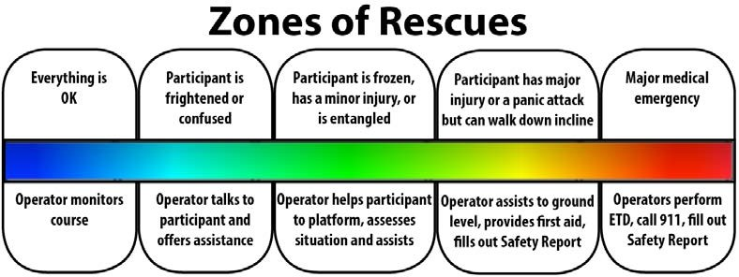
Operator monitors course | Operator talks to participant and offers assistance | Operator helps participant, assesses situation and assists | Operator assists to ground level, provides first aid, fills out safety report | Operator perfom first aid, call emergency numbers, fill out safety report

4.7 INSPECTING SAFETY EQUIPMENT
- All safety equipment must be inspected thoroughly prior to use. The following is a list of failure criteria for safety equipment:
- Frays: | Any webbing, stitching, rope or wires that are unraveling or becoming worn at the edges.
- Abrasions | Any webbing, stitching or rope that has damaged caused from scraping, dragging or friction that does not cause melting.
- Cuts/rips/punctures: | Any webbing, stitching, rope or wires that have been damaged by a sharp object.
- Warping: | Any webbing, stitching, rope, wires, buckles or other hardware that has a permanently altered shape caused by impact loads or other stressors.
- Chemical exposure: | Any webbing, stitching or rope that has been exposed to harsh chemicals such as bleach or ammonia. This may not always cause discoloration.
- Glazing: | Any webbing, stitching or rope that is melted caused by heat or friction that is not a part of the original design.
- Discoloration: | Any webbing, stitching, rope or hardware that has been permanently discoloured due to excessive UV exposure, chemical exposure, paint or bodily fluids.
- Alterations | Any equipment that has been altered from its original design.

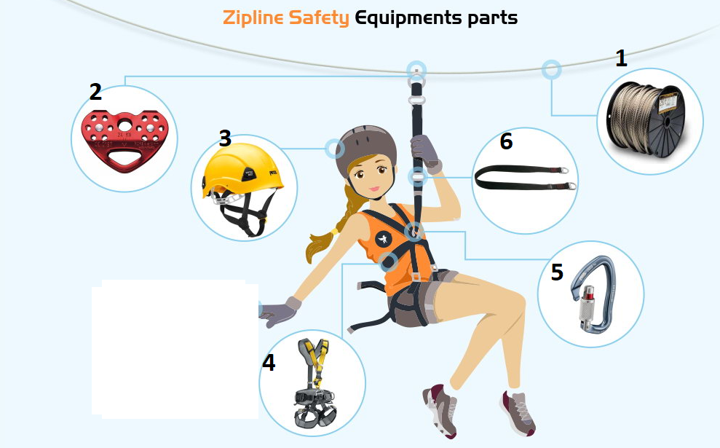
1 – Zipline Cable
2 – Pulley
3 – Safety Helmet
4 – Harness
5 – Carabiner
6 – Sling line

4.7.1 Damaged Equipment Label
Damaged equipment labels should be filled out and connected to any equipment that is in questionable condition. This is required before sending equipment for repair.
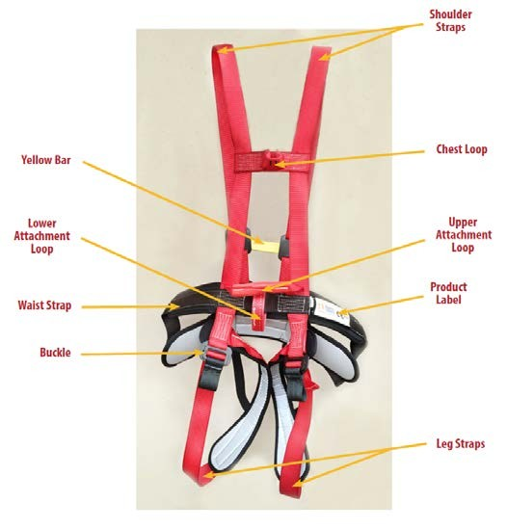
4.7.2 Harnesses
All harnesses must be inspected thoroughly prior to use. Failure to inspect harnesses prior to use may result in serious injury or death.

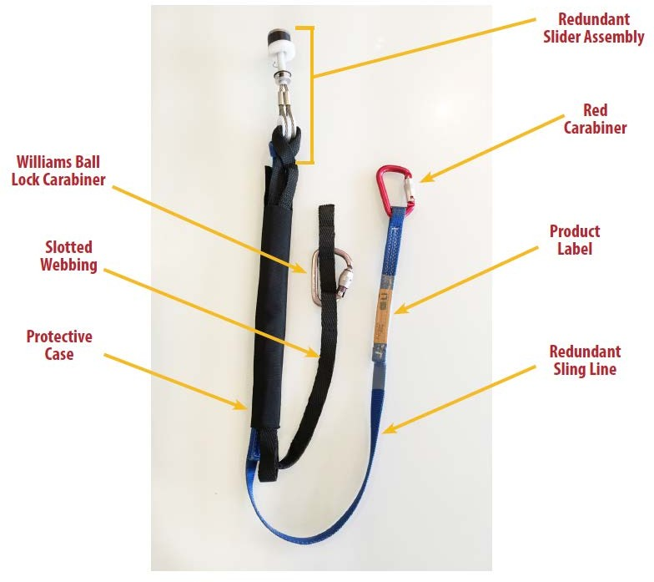
4.7.3 Sling Lines
All sling lines must be inspected thoroughly prior to use. Failure to inspect sling lines prior to use may result in serious injury or death.

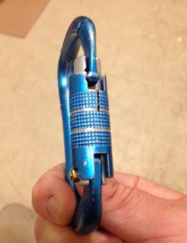
4.7.4 Carabiners
An acceptable carabiner must open and close easily and smoothly, and there must be no wear on the metal greater than 10% of the original diameter.

4.7.5 Pulley
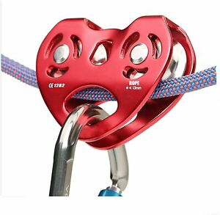
A pulley is made up of a grooved wheel known as a sheave is used in zip-lines, and the pulley turns as it travels along, thus reducing friction and enabling greater speed. At the are cables connected between two points that slope downward. Passengers are fitted with a body harness that clips into the cable via a pulley. These pulleys are designed to reduce friction, allowing the rider to accelerate down the line at grin-inducing speeds.
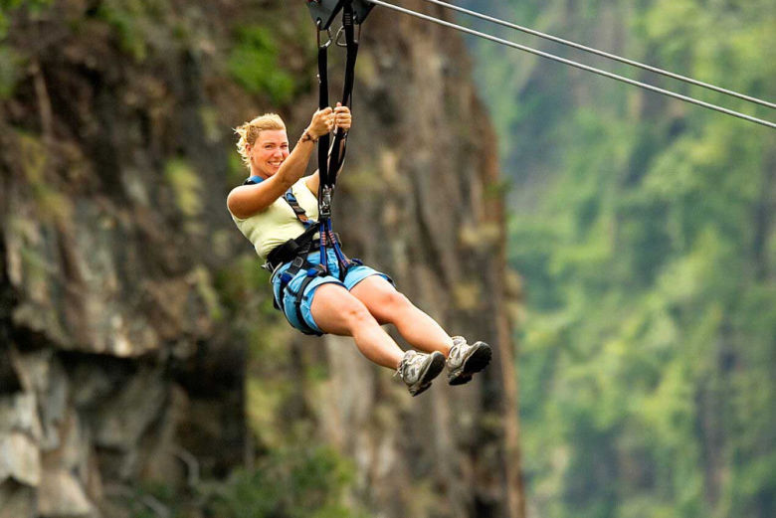
4.7.6 Back up Rope
A back up rope is made up of carabina and rope that secures the person to the zip line in addition to the pulley. The back up rope is designed to act as protection in the event of a problem with the pulley rope.

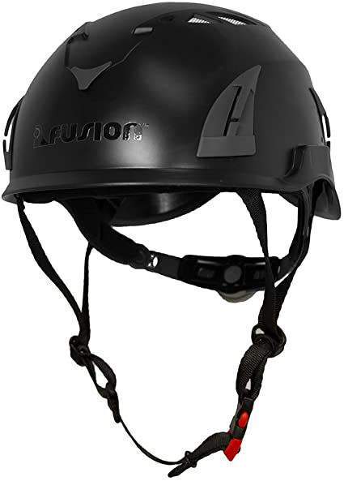
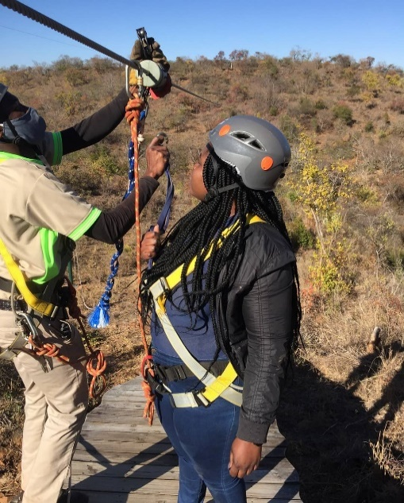
4.7.7 Helmet
A helmet can meaningfully reduce the risk of head injury to a participant in the event of a fall. Even exiting off the landing platform has potential for a fall.

4.7.8 Breaking System
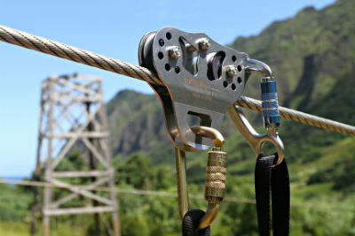
The zip line will have a padded block with a length of bungee rope attached. This stretchy rope will move with the rider until it tightens enough to slow their momentum before retracting, bringing the rider back to the lowest point of the zip line.

4.7.9 Breaking Rope
The zip line breaking cable will have galvanised twisted cables

4.7.8 Go Pros
A GoPro is a small camera that will attached to client wrist before zipping it takes the best qualities of point-and-shoots and camcorders and packs them into a rugged frame that's smaller, waterproof, and virtually durable.
4.7.8 Weight
The zip line weight are for additional heaviness for those who are light weight.

5.0 SECTION E - QUAD BIKE

Quad Bike is designed especially for off-road driving experiences which is guaranteed to leave you thrilled to the bones, a quad bike is a four-wheeled beast that will help you bounce across the terrain.


Before a ride take to the track the Quad Instructor must give a safety briefing to the rider inorder for the rider to feel safe and know the correct code of conduct when riding a motorbike or quad-bike.

5.1 RIDER RULES AND RESPONSIBILITIES
- Rider must agree to indemnify and hold harmless the campsite and such persons or body as may be authorised by Blue Hills Camp.
- Rider must be 18 years or older, if the rider is under 18 years of age, a parent/guardian will be required to be present to sign the indemnity terms and conditions provided to each rider before each quad trek.
- Riders must declare themselves/their child to be physically and mentally fit and competent to participate in this activity.
- The rider must recognise and accept the risk involved with this activity and only attempt the features and obstacles of the track that are suitable for their level of ability. The quad instructor will give alternative routes/options on treks and riders are expected to not attempt anything they do not feel comfortable with.
- Helmets must be worn at all times whilst riding. Boots, body protection, and appropriate attire is also recommended.
- Watch roads carefully as animals and other vehicles can come into the roads suddenly without warning. Damage to animals and property will be charged accordingly.
- Quad bikes should only be ridden in the presence of a Blue Hills Camp instructor.
- No alcohol or drugs are to be consumed before or during use of the facilities. If the organisers suspect alcohol or drugs have been consumed before or during the quad trek they have the right to refuse use of the facilities.
- Blue Hills Camp cannot accept any liability for adverse weather, by attending it is deemed you have accepted the prevailing weather conditions. If the weather is too poor for the quad trek to take place Blue Hills Camp will contact you to reschedule as soon as the decision is made.
- Blue Hills Camp quad reserve the right to immediately eject anyone who is, in their opinion, riding in a careless or dangerous manner, or causing damage, nuisance or annoyance to others. This is primarily for the safety of riders and others as well as to help Blue Hills Camp maintain their quad bikes to a safe standard. No return or refund will be offered, and Blue Hills Camp reserve the right to recover any costs incurred.
- Right of way must be given to any other vehicles and pedestrians.
- Riders needs to inform the Blue Hills Camp instructor of any previous/current medical conditions or disability (e.g. heart problems, breathing issues, learning difficulties etc.) which could impact on their safety or wellbeing during the quad trek before the session starts. If you are unsure, speak to the administration staff at the time of booking.
- It is expected riders will listen to the quad safety briefing and will adhere to the requirements therein.
- In the case of an accident the instructor must immediately notify the Operator Supervisor / manager
- In the event of any accident participant may be asked to fill out a safety report. It is important to report accidents and fill out a safety report. This can help determine the cause of the accident and the actions to prevent other participants from injuring themselves. If the accident was caused by an operator or course error this must be addressed immediately. If the accident was caused by the behavior or actions of the participant, filling out the proper paperwork can help with preventing a further claim by the participant.

5.2 PHYSICAL LIMITATION

Riders must meet the following physical limitations to be permitted to ride the Quad bike:

- Those with any impairment that would prevent normal seating or use of the safety restraints as provided.
- Passengers with physical disabilities must be able to be secure in the restraints.
- All legs must be present to the knee at a minimum.
- Prosthetics are not allowed on the ride.

5.3 MEDICAL LIMITATION

Riders with the following medical conditions should not be allowed to take part:

- Expectant mothers.
- Persons with neck or back problems.
- Persons with heart conditions.
- Persons who have had recent surgery.
- Those with any impairment that would prevent normal seating or use of the safety restraints as provided.
- Persons with any other condition that they may be aware of that may result in injury or complication.

5.4 WEATHER RESTRICTIONS
Do not drive in excessively poor conditions (weather, visibility or surface).
The following environmental conditions must be observed in regards to weather conditions:
- Thunder/Lightning Storms
- Extreme heat
- Rain

5.5 INSPECTING SAFETY EQUIPMENT
- All safety equipment must be inspected thoroughly prior to use. The following is a list of failure criteria f or safety equipment see ANNEX 6 for detailed checklist.
- tyres
- steering and suspension bushes
- front and rear shock absorbers
- front and rear brake
- throttle
- drive chain
- oil level
- fuel level and fuel line

5.6 QUAD BIKE MAINTENANCE
Good maintenance is critical to the safety of all quad bikes. Critical elements of an effective maintenance programme include:
- Pre-start operator checks
- General maintenance Scheduled
- mechanical servicing checks
- Vehicle damage reporting and repair

5.6.1 Daily maintenance checks
The quad bike must be regularly serviced to a schedule which considers the quad bike’s hours and levels of use. In between services the quad bike should be regularly inspected for any faults or problems.
A quad bike operator must check their vehicle for the following before each use:
- Tyre pressures and condition
- Brakes front and back
- Steering
- Fuel
- Oil levels
- All after-market attachments are secure and good condition
- Tool kit is present and complete
5.6.2 General maintenance checks
- The general maintenance needs to be completed regularly by the quad bike operator and at no less than fortnightly intervals.
- Wash the vehicle regularly
- Remove and clean or replace the air filter
- Ensure controls, especially the throttle and brakes, are checked and adjusted regularly
- After riding through water, check brakes

5.6.3 Scheduled Mechanical maintenance checks
- Mechanical servicing checks must be done by a suitably qualified person.

5.6.4 Breakdowns and/or damage
- A quad bike must not be operated if it is due for a service or has any obvious mechanical faults which cannot be fixed by the operator.
- If a mechanical problem occurs in the field, inspect the vehicle and try and fix the problem with the tool kit.
- Only continue to ride if there is no increased risk to the operator and if it will not further damage the vehicle.
- Otherwise park the vehicle somewhere safe, take the key and call or walk to get assistance.
- Take care to note the exact location so another staff member can easily find it, if necessary.
- Any damages to the quad bike must be operated
- Any personnel injures the operator, should record

5.7 WORK PROCEDURE
Only permitted operator is allowed to use this equipment.
5.7.1 Personal Protective Equipment
- Wear an approved helmet.
- Wear suitable clothing, including long trousers and boots.
5.7.2 Pre-Operational Safety Checks
- Follow manufacturer’s recommendations and warning labels.
- Locate and ensure you are familiar with all machine operations, controls and warnings.
- Check fuel, tyres, guards, drive line and brakes as recommended by the manufacturer.
- Quad bike will only be used if it has passed the check list as per the operator.
- After use remove any foreign material from in and around engine parts.

5.7.3 Operational Safety
- Never carry any passengers
- Observe speedlimits and no-go areas.
- Drive at speed slow enough to keep control over unexpected hazards.
- Travel up/down slopes rather than across, taking extra care when ascending or descending slopes or riding over uneven ground, travel in a line 5metre apart.
- Take care when refuelling to avoid spilling fuel onto hot motor or exhaust if any wipe or let it cool down for 5min.
- Ensure no person or animal is endangered when operating equipment.
- Advise your supervisor of any mechanical problems and do not ride a quad bike that is not in good condition.
- Switch off engine when refuelling.

5.8 END OF DAY OPERATION
- Park on even ground.
- Lock the parking brake.
- Stop the engine and remove the keys.
- Hand over keys to Front Office for safety
- Remove any foreign material from in and around engine parts.
- Operator check for damages and report if found.

6.0 SECTION F - MOUNTAINEERING

6.1 RULES AND RESPONSIBILITIES
- Participants must agree to indemnify and hold harmless the campsite and such persons or body as may be authorised by Blue Hills Camp.
- Participants must be 18 years or older, if the participants is under 18 years of age, a parent/guardian will be required to be present to sign the indemnity terms and conditions provided to each participant before mountaineering.
- Participants must carry water to avoid hydration
- Climbers must declare themselves/their child to be physically and mentally fit and competent to participate in this activity.
- Participants should only go mountaineering in the presence of a Blue Hills Camp instructor.
- No alcohol or drugs are to be consumed before or during use of the walk. If the instructor suspect alcohol or drugs have been consumed before or during they have the right to refuse the participant
- Blue Hills Camp cannot accept any liability for adverse weather, by attending it is deemed you have accepted the prevailing weather conditions. If the weather is too poor for mountaineering to take place Blue Hills Camp will contact you to reschedule as soon as the decision is made.
- Blue Hills Camp quad reserve the right to immediately eject anyone who is, in their opinion causing damage, nuisance or annoyance to others.
- Participants needs to inform the Blue Hills Camp instructor of any previous/current medical conditions or disability (e.g. heart problems, breathing issues, learning difficulties etc.) which could impact on their safety or wellbeing during the mountaineering before the session starts. If you are unsure, speak to the administration staff at the time of booking.
- It is expected participants will listen to the mountaineering safety briefing and will adhere to the requirements therein.
- Participants must have secure shoes. No bare feet, flip-flops or open heel shoes.
- In the case of an accident, a manager must be notified and the operator, manager
- In the event of any accident participant may be asked to fill out a safety report. It is important to report accidents and fill out a safety report. This can help determine the cause of the accident and the actions to prevent other participants from injuring themselves. If the accident was caused by an operator or course error this must be addressed immediately. If the accident was caused by the behavior or actions of the participant, filling out the proper paperwork can help with preventing a further claim by the participant.

6.2 PHYSICAL LIMITATION

Climbers must meet the following physical limitations to be permitted to go mountain hiking

- Those with any impairment that would prevent normal walking
- Prosthetics are not allowed on the walk.

6.3 MEDICAL LIMITATION

Climbers with the following medical conditions should not be allowed to go mountain hiking

- Expectant mothers.
- Persons with neck or back problems.
- Persons with heart conditions.
- Persons who have had recent surgery.
- Those with any impairment that would prevent normal walking
- Persons with any other condition that they may be aware of that may result in injury or complication.

6.4 WEATHER RESTRICTIONS
The following environmental conditions must be observed in regards to weather conditions:
- Thunder/Lightning Storms
- Extreme heat
- Rain

7.0 SECTION G - PUTT PUTT


7.1 RULES AND RESPONSIBILITIES
- Parties playing together limited to flour (4) persons
- Initial stroke on each hole must be played from tee matts
- If ball leaves putting surface, replace at spot it went out and take one stroke penalty.
- When ball enters trap, replace it to fairway and take one stroke penalty
- Player may move the ball 150mm from any obstruction at no penalty.
- If player’s ball is hit by another ball, new position may be taken unless ball has been hit into cup in which case player MUST take old position and shoot, use markers.
- Player(s) to leave putting surface immediately after the last put is made
- Player to play six (6) stroke limit on all holes.

8.0 SECTION H - BIKING


Biking is designed especially for off-road driving experiences which is guaranteed to leave you thrilled and enjoying the most beautiful nature scenery imaginable and feeling the cool brief of air .

Before a ride take to the track the bike Instructor must give a safety briefing to the rider inorder for the rider to feel safe and know the correct code of conduct when riding a bike.

8.1 RIDER RULES AND RESPONSIBILITIES
- Rider must agree to indemnify and hold harmless the campsite and such persons or body as may be authorised by Blue Hills Camp.
- Rider must be 18 years or older, if the rider is under 18 years of age, a parent/guardian will be required to be present to sign the indemnity terms and conditions provided to each rider before each quad trek.
- Riders must declare themselves/their child to be physically and mentally fit and competent to participate in this activity.
- The rider must recognise and accept the risk involved with this activity and only attempt the features and obstacles of the track that are suitable for their level of ability. The bike instructor will give alternative routes/options on treks and riders are expected to not attempt anything they do not feel comfortable with.
- Helmets must be worn at all times whilst riding. Boots, body protection, and appropriate attire is also recommended.
- Watch roads carefully as animals and other vehicles can come into the roads suddenly without warning. Damage to animals and property will be charged accordingly.
- Bikes should only be ridden in the presence of a Blue Hills Camp instructor.
- No alcohol or drugs are to be consumed before or during use of the facilities. If the organisers suspect alcohol or drugs have been consumed before or during the quad trek they have the right to refuse use of the facilities.
- Blue Hills Camp cannot accept any liability for adverse weather, by attending it is deemed you have accepted the prevailing weather conditions. If the weather is too poor for the quad trek to take place Blue Hills Camp will contact you to reschedule as soon as the decision is made.
- Blue Hills Camp quad reserve the right to immediately eject anyone who is, in their opinion, riding in a careless or dangerous manner, or causing damage, nuisance or annoyance to others. This is primarily for the safety of riders and others as well as to help Blue Hills Camp maintain their quad bikes to a safe standard. No return or refund will be offered, and Blue Hills Camp reserve the right to recover any costs incurred.
- Right of way must be given to any other vehicles and pedestrians.
- Riders needs to inform the Blue Hills Camp instructor of any previous/current medical conditions or disability (e.g. heart problems, breathing issues, learning difficulties etc.) which could impact on their safety or wellbeing during the quad trek before the session starts. If you are unsure, speak to the administration staff at the time of booking.
- It is expected riders will listen to the quad safety briefing and will adhere to the requirements therein.
- In the case of an accident the instructor must immediately notify the Operator Supervisor / manager
- In the event of any accident participant may be asked to fill out a safety report. It is important to report accidents and fill out a safety report. This can help determine the cause of the accident and the actions to prevent other participants from injuring themselves. If the accident was caused by an operator or course error this must be addressed immediately. If the accident was caused by the behavior or actions of the participant, filling out the proper paperwork can help with preventing a further claim by the participant.

8.2 PHYSICAL LIMITATION

Riders must meet the following physical limitations to be permitted to ride the Quad bike:

- Those with any impairment that would prevent normal seating or use of the safety restraints as provided.
- Passengers with physical disabilities must be able to be secure in the restraints.
- All legs must be present to the knee at a minimum.
- Prosthetics are not allowed on the ride.

8.3 MEDICAL LIMITATION

Riders with the following medical conditions should not be allowed to take part:
- Expectant mothers.
- Persons with neck or back problems.
- Persons who have had recent surgery.
- Persons with any other condition that they may be aware of that may result in injury or complication.

8.4 WEATHER RESTRICTIONS
The following environmental conditions must be observed in regards to weather conditions:
- Thunder/Lightning Storms
- Extreme heat
- Rain

8.5 INSPECTING SAFETY EQUIPMENT
- All safety equipment must be inspected thoroughly prior to use.

8.6 BIKE MAINTENANCE
Good maintenance is critical to the safety of all bikes. Critical elements of an effective maintenance programme include:
- Pre-start operator checks
- General maintenance Scheduled
- mechanical servicing checks
- Bike damage reporting and repair

8.6.1 Daily maintenance checks
The bike must be regularly serviced to a schedule which considers the bike’s hours and levels of use. In between services the bike should be regularly inspected for any faults or problems.
A quad bike operator must check their vehicle for the following before each use:
- Tyre pressures and condition
- Brakes front and back
8.6.2 General maintenance checks
- The general maintenance needs to be completed regularly by the bike operator and at no less than fortnightly intervals.
- Wash the bike regularly
- Ensure controls, especially the brakes, are checked and adjusted regularly
8.6.3 Scheduled Mechanical maintenance checks
- Mechanical servicing checks must be done by a suitably qualified person.
8.6.4 Breakdowns and/or damage
- A bike must not be operated if it is due for a service or has any obvious mechanical faults which cannot be fixed by the operator.
- If a mechanical problem occurs in the field, inspect the bike and try and fix the problem with the tool kit.
- Only continue to ride if there is no increased risk to the rider and if it will not further damage the bike.
- Otherwise park the bike somewhere safe, and call or walk to get assistance.
- Take care to note the exact location so another staff member can easily find it, if necessary.
- Any damages to the bike must be operated
- Any personnel injures the operator, should record

8.7 WORK PROCEDURE
Only permitted operator is allowed to use this equipment.
8.7.1 Personal Protective Equipment
- Wear an approved helmet.
- Wear suitable clothing, including long trousers and boots.
8.7.2 Pre-Operational Safety Checks
- Follow manufacturer’s recommendations and warning labels.
- Locate and ensure you are familiar with all machine operations, controls and warnings.
- Check, tyres, guards and brakes as recommended by the manufacturer.
- Use remove any foreign material from the bike.

8.7.3 Operational Safety
- Never carry any passengers
- Ride at speed slow enough to keep control over unexpected hazards.
- Travel up/down slopes rather than across, taking extra care when ascending or descending slopes or riding over uneven ground.
- Ensure no person or animal is endangered when operating equipment.
- Advise your supervisor of any mechanical problems and do not ride the bike that is not in good condition.

8.8 END OF DAY OPERATION
- Park on even ground.
- Lock the parking brake.
- Remove any foreign material from the bike.
- Check for damage and report if found.

9.0 SECTION I– CO-ORDINATION WITH OTHER DEPARTMENTS
No work is complete without coordination and documentation with the other departments.
INTER-DEPARTMENTAL

9.1 ACTIVITIES CO-ORDINATION WITH FRONT-OFFICE
The co-operation between Activity and front office should be very intimate or close. Front office communicates the daily arrival list to the Activity Department and it helps the operators to forecast their workplan. Front office also assists guests in making their activities choices and helps in marketing the Activity Department .

9.2 ACTIVITIES CO-ORDINATION WITH HUMAN RESOURCE
Activities co-ordinates with the Human Resource department for recruitment of staff, to find the skilled people for the department. Activities highlight the training and development required by their staff and communicates it to the training department, who then prepares the training calendars and train people accordingly. Appraisals and career developing of the Activities department is raised with the Human Resource department. Joining formalities of the new staff, induction, orientation, accommodation facilities etc. are dealt by Human Resources department. The HR also comes up with Personal policy on staff meals, shares staff meal cost with personnel department.

9.3 ACTIVITIES CO-ORDINATION WITH PURCHASE& STORES
The purchase and stores department helps the Activities in purchasing and stocks of various consumables used in Activity department. Activities also receive the consumables at receiving bay, thereby ensuring that the right quality of consumables are purchased as per the standards specified.

9.4 ACTIVITIES CO-ORDINATION WITH SECURITY
The relation between Activity department and Security is important as the Security Department oversees items taken out and in of the campsite.

9.5 ACTIVITIES CO-ORDINATION WITH MAINTENANCE
Maintenance department does the preventive and breakdown maintenance of the equipment used by the Activity Department. It helps in installation of new equipment and trains the staff in its usage and precautions. Coordinates with operators to utilize the resources effectively to minimize costs and increase profits. Maintenance schedules are made and followed up by operators. Safety procedures are laid down by the maintenance and followed up by the operators.

9.6 ACTIVITIES CO-ORDINATION WITH SALES AND MARKETING
The relation between Activity Department and sales marketing is important as the sales and marketing informs the Activity of the occupancy forecast be it weekly, monthly and yearly.

9.7 ACTIVITIES CO-ORDINATION WITH FINANCE DEPARTMENT
The Finance Department does the costing of the Activities and this helps the management to decide upon the Activity Price to get the desirable profits . Finance helps operators to keep a check on their expenses by giving a periodic report mentioning their profits and losses.

ANNEXES
ANNEX 1: | ZIPLINE TOUR NOTICE
ANNEX 2: | ZIPLINE INDEMNITY FORM
ANNEX 3: | ZIPLINE CHECKLIST
ANNEX 4: | QUAD BIKE TERMS AND CONDITIONS BOOKING FORM
ANNEX 5: | QUAD BIKE INDEMNITY FORM
ANNEX 6: | QUAD BIKE DAILY PRE-START AND RIDE CHECKLIST
ANNEX 7: | SAFETY REPORT
ANNEX 8: | EMERGENCY ACTION PLAN CONTACTS


ANNEX 1 : ZIP LINE TOUR NOTICE

All tour participants must receive training and sign waiver before participating

The following requirements are subject to change based on weather conditions and operator
discretion.

Participant must be:
1. At least 18 years old. All children under 16 must be accompanied by a paid parent/ guardian or paid tour guide who is 18 years and above or paid guide during the entire tour experience at the same time as the child and they must also sign this liability waiver as the Undersigned of the minor child during the orientation process (children 16-17 may participate alone, but must have a parent or guardian 18 years or older present at the orientation to sign this liability waiver as their Undersigned) able to comprehend and follow all safety instructions
- Age minimum age has to be 1year 6months
- Weigh between 27kgs and 125kgs.
- able to fit properly within the safety harness
- physically able to:
- climb up and down stairs and a suspension bridge
- put on safety harness;
- hold arms above head for 2 minutes
- hold legs apart for 2 minutes
- hold and carry a 1kg trolley for several minutes,
- Demonstrate all rider positions.

2. In addition to the above, Participant understands that:
- No loose jewellery or personal items are permitted.
- Participant will be given use of locked storage for keys, phone, camera, etc.
- No food & beverage is permitted on the tour;
- hair must be secured so that it cannot come in contact with zip line apparatus
- Appropriate footwear is required—shoes must be closed toed and secure (will stay on foot during tour), provide stability and be suitable for climbing stairs, ladders and walking on a platform with 1” holes. For example, flip-flops, wedges, high heels, mules and sandals are not considered appropriate;

3. Additional restrictions may apply based on weather conditions.

4. We reserve the right to disqualify any participant based on tour operator judgment.

ANNEX 2 :ZIPLINE INDEMNITY FORM

1. I………………………………………………………………………………………………………………(the participant) do hereby affirm and acknowledge that I have been informed and I understand the terms and conditions for me to be able to participate in Ziplining at Blue Hills Camp, Umzingwane. I hereby agree, acknowledge and appreciate that:
- Individuals with health concerns, including but not limited to the following:
- Spinal cord, Neck, back or shoulder problems
- Injuries, pain or instability
- Heart conditions or disease
- Seizure disorders or problems with balance
- Women who are pregnant
Should not participate in this tour.
NB: This list is not exhaustive and any other concerns must immediately be brought to the attention of the guide.

- I UNDERSTAND THAT PARTICIPANTS MAY NOT BE UNDER THE INFLUENCE OF ALCOHOL OR ANY SUBSTANCE THAT MIGHT IMPAIR JUDGEMENT OR PHYSICAL CAPABILITY. BLUEHILLS CAMP STAFF MAY REFUSE ME TO PARTICIPATE IN ZIPLINING IF I EXHUME CHARACTERISTICS OF A PERSON UNDER THE INFLUENCE OF SUCH SUBSTANCE AND I WILL NOT BE REFUNDED. I MUST OBSERVE ALL TRAINING AND SAFETY INSTRUCTIONS.

- By signing this waiver, I warrant that I meet the above criteria and I acknowledge that participating in the tour experience and on the premises can be a hazardous and a strenuous activity.

- I understand that the excursion allows tour participants, while sitting in a harness suspended from a high-tension cable, to travel/glide from an elevated launch platform to a landing tower/platform via a gravity-based pulley system high above the ground.
5.1 The tour may also include climbing in and out of a vehicle, climbing up/down extensive staircases and across a suspension bridge, and some walking across uneven terrain.
5.2 The tour participants may also sustain minor or major injuries, including but not limited to cuts, bruises, bumps, bruises, scrapes, muscle strains, friction burns and/or insect bites.
5.3 I UNDERSTAND, RECOGNIZE AND ACKNOWLEDGES THAT THERE MAY BE RISKS NOT LISTED HEREIN.
5.4 I have voluntarily elected to participate in the tour experience despite the recognized, inherent, and even unforeseen dangers, and despite the known and unknown risks of harm presented thereby.
5.5 I have been provided with training (given prior to start of tour by the guide) and have viewed an instructional presentation which contains information on various policies, procedures, training points, and other information relative to participation.
  - BLUE HILLS CAMP reserves the right to use voice, video, photographic or other images of the participants
for quality control, safety, security and promotional purposes.

6. For and in consideration of permitting the Undersigned to participate in the zip line experience on premises, the Undersigned hereby voluntarily releases, discharges, waives and relinquishes any and all actions or causes of action for personal injury, property damage or wrongful death occurring to him/herself arising in any way as a result of his/her participation or any activities incidental thereto, wherever or however the same may occur and for whatever period said activities may commence and continue, and agrees that under no circumstances will he/she prosecute or present any such claim against BLUE HILLS CAMP ZIP LINES, and any of their officers, agents, servants, contractors, and employees for any said cause of action, whether the same shall arise by the negligence of BLUE HILLS CAMP, and any of their officers, agents, servants, contractors, and employees, or otherwise.
6.1 I agree that in the event any claim for personal injury, property damage or wrongful death shall be made or prosecuted against BLUE HILLS CAMP ZIP LINES, or any of their officers, agents, servants, contractors, and employees arising as a result of my participation in the tour on the premises, I shall indemnify and save BLUE HILLS CAMP ZIP LINES and their officers, agents, servants, contractors, and employees, from and against any and all liability for damage or injury of any kind or nature arising out of my participation in the tour on premises or any activities incidental thereto, inclusive of attorney fees and litigation costs, even if the liability or damage results from the sole negligence of BLUE HILLS CAMP ZIP LINES, and their officers, agents, servants, contractors, and employees.
6.2. I agree to release all parties from any claims by my heirs, dependents, estates, assigns, personal representatives, and next of kin Initial:
Participant:…………………………………………………Witness: …………………………………………
7. I acknowledge that I have read the above and expressly agree to assume the risk of participation in the zip line tour on BLUE HILLS premises and any activities incidental thereto and I am voluntarily signing this waiver, and further represents no oral representation statements or inducements apart from the foregoing written agreement have been made.

………………………….. ……………………………………… ………………………………
Dated Print Full Name Signature of Participant

……………………………………..………………………………………………………………………………..
Participant’s Address

………………………………… ............……………………………………….. ............………………………
City Home/Mobile Phone Number Email Address

OFFICIAL USE ONLY:

Tour Time: _______________________ Guide Initial: ____________


ANNEX 3 :ZIPLINE CHECKLIST

- Pre-Us Inspection:
Safety Equipment
☐Harnesses ☐Slider Assemblies/ SlingLines
☐Surrounding Area ☐Steel Structure
☐Nut s& Bolts ☐Helmet

- Activity SetUp:
- All access restrictions removed
- Set out harnesses and slider/sling lines
- Set up any stored away entrance access

- Outfitting:
- Check all participants for harness fit*
*Shoulder straps snug and don’t come down over shoulders.
*All buckles properly buckled and snug.
- Attach and adjust slider/slingline
- Participants must see operator to remove their harness

- Activity Closing:
- Equipment taken down and stored properly
- All access restrictions replaced
- Store all harnesses and slider/sling lines
- Check area for lost articles
- Put up any removable entrance access

- Operator Reports:
- Accidents/Incidents* ☐ Course maintenance or repair needed
*Fill out Safety Report if any accidents are reported.

DATE…………………………………………………………..
TIME…………………………………………………………..
CHECKED BY:-……………………………………………………..


.
ANNEX 4 :QUAD BIKE TERMS AND CONDITIONS

BOOKING FORM/CONTACT US TERMS AND CONDITIONS
- All bookings are subject to availability
- We will only use your contact details (name, email address and phone number) for the purposes of booking a quad adventure for you. Your information will not be passed onto a third party. By sending us a booking request or contact form you are agreeing to provide us your contact details for these purposes.
QUAD TREK TERMS AND CONDITIONS
Here at Blue Hills Camp we make sure that your outdoor adventures are safe and reliable so that you can focus on having fun. Before we take to the track our Quad Instructors will give a safety briefing to ensure you feel safe and know the correct code of conduct when riding a motorbike or quad-bike. Below is a copy of our terms and conditions and indemnity rules that you will be asked to sign before taking to your off road adventure, feel free to get a head start and read through the conditions to make sure you feel comfortable with the procedure. We also have an FAQ's section where you can find out all the necessary information to prepare for your big day out, alternatively you can contact us and one of our friendly Customers Services Officer will attend to your questions.
Terms and Conditions
- Riders must agree to indemnify and hold harmless the campsite and such persons or body as may be authorised by Blue Hills Camp.
- Riders must declare themselves/their child to be physically and mentally fit and competent to participate in this activity.
- The rider must recognise and accept the risk involved with this activity and only attempt the features and obstacles of the track that are suitable for their level of ability. The quad instructor will give alternative routes/options on treks and riders are expected to not attempt anything they do not feel comfortable with.
- Helmets must be worn at all times whilst riding. Boots, body protection, and appropriate attire is also recommended.
- Watch roads carefully as animals and other vehicles can come into the roads suddenly without warning. Damage to animals and property will be charged accordingly.
- Quad bikes should only be ridden in the presence of a Blue Hills Camp instructor.
- No alcohol or drugs are to be consumed before or during use of the facilities. If the organisers suspect alcohol or drugs have been consumed before or during the quad trek they have the right to refuse use of the facilities.
- If the rider is under 18 years of age, a parent/guardian will be required to be present to sign the indemnity terms and conditions provided to each rider before each quad trek.
- Blue Hills Camp cannot accept any liability for adverse weather, by attending it is deemed you have accepted the prevailing weather conditions. If the weather is too poor for the quad trek to take place Blue Hills Camp will contact you to reschedule as soon as the decision is made.
- Blue Hills Camp quad instructors reserve the right to immediately eject anyone who is, in their opinion, riding in a careless or dangerous manner, or causing damage, nuisance or annoyance to others. This is primarily for the safety of riders and others as well as to help Blue Hills Camp maintain their quad bikes to a safe standard. No return or refund will be offered, and Blue Hills Camp reserve the right to recover any costs incurred.
- Right of way must be given to any other vehicles and pedestrians.
- Riders needs to inform the Blue Hills Camp instructor of any previous/current medical conditions or disability (e.g. heart problems, breathing issues, learning difficulties etc.) which could impact on their safety or wellbeing during the quad trek before the session starts. If you are unsure, speak to the administration staff at the time of booking.
- It is expected riders will listen to the quad safety briefing and will adhere to the requirements therein.
- Deposits are non-refundable however you can reschedule in extenuating circumstances if at least 48 hours’ notice is given. This is at the discretion of the administration staff. Riders who turn up late may be restricted to less time if other bookings follow their session however the full cost of the activity will still be payable. A full copy of this form will be presented on site and required to be signed on the day of your outdoor events and before taking to the track.


ANNEX 5 :QUAD BIKE INDEMNITY FORM

I……………………………………………………………………………………………....do hereby affirm and acknowledge that I have been informed and I understand the terms and conditions for me to be able to participate in Quad bike riding at Blue Hills Camp, Umzingwane. I agree to indemnify and hold harmless the campsite and such persons or body as may be authorised by Blue Hills Camp.
- I declare myself/my child physically and mentally fit and competent to participate in this activity.
- I recognise and accept the risk involved in taking part in this activity and the features and obstacles of the track is suitable for my level of ability.
- I will wear a protective helmet at all time while riding and that I will not ride off the prescribed track
I UNDERSTAND THAT PARTICIPANTS MAY NOT BE UNDER THE INFLUENCE OF ALCOHOL OR ANY SUBSTANCE THAT MIGHT IMPAIR JUDGEMENT OR PHYSICAL CAPABILITY. BLUEHILLS CAMP STAFF MAY REFUSE ME TO PARTICIPATE IN PARTICIPATING IF I EXHUME CHARACTERISTICS OF A PERSON UNDER THE INFLUENCE OF SUCH SUBSTANCE AND I WILL NOT BE REFUNDED. I MUST OBSERVE ALL TRAINING AND SAFETY INSTRUCTIONS.
By signing this waiver, I acknowledge that participating in the tour experience and on the premises can be a hazardous and a strenuous activity. The tour participants may also sustain minor or major injuries, including but not limited to cuts, bruises, bumps, bruises, scrapes, muscle strains, friction burns and/or insect bites.
- I UNDERSTAND, RECOGNIZE AND ACKNOWLEDGES THAT THERE MAY BE RISKS NOT LISTED HEREIN. I have voluntarily elected to participate in the tour experience despite the recognized, inherent, and even unforeseen dangers, and despite the known and unknown risks of harm presented thereby. The Undersigned has been provided training (given prior to start of tour) and has viewed an instructional presentation which contains information on various policies, procedures, training points, and other information relative to participation. BLUEHILLS CAMP reserves the right to use voice, video, photographic or other images of the participants for future marketing, educational, or other purposes without compensation. For and in consideration of permitting the undersigned to participate in the quad bike ride experience on premises, the Undersigned hereby voluntarily releases, discharges, waives and relinquishes any and all actions or causes of action for personal injury, property damage or wrongful death occurring to him/herself arising in any way as a result of his/her participation or any activities incidental thereto, wherever or however the same may occur and for whatever period said activities may commence and continue, and agrees that under no circumstances will he/she prosecute or present any such claim against Blue Hills Camp Quad Bikes, and any of their officers, agents, servants, contractors, and employees for any said cause of action, whether the same shall arise by the negligence of Blue Hills Camp, and any of their officers, agents, servants, contractors, and employees, or otherwise.
- I agree that in the event any claim for personal injury, property damage or wrongful death shall be made or prosecuted against BLUE HILLS CAMP QUAD BIKES, or any of their officers, agents, servants, contractors, and employees arising as a result of my participation in the tour on the premises, I shall indemnify and save BLUE HILLS CAMP QUADBIKES and their officers, agents, servants, and employees, from and against any and all liability for damage or injury of any kind or nature arising out of my participation in the tour on premises or any activities incidental thereto, inclusive of attorney fees and litigation costs, even if the liability or damage results from the sole negligence of BLUE HILLS CAMP QUAD BIKES, and their officers, agents, servants, contractors, and employees.
- I agree to release all parties from any claims by my heirs, dependents, estates, assigns, personal representatives, and next of kin
- I acknowledge that I have read the above and expressly agree to assume the risk of participation in the zip line tour on BLUE HILLS premises and any activities incidental thereto and I am voluntarily signing this waiver, and further represents no oral representation statements or inducements apart from the foregoing written agreement have been made.

………………… ….. …………………………………………………………………...
Date Print Full Name Signature of Participant
………................………………………………………………………………………………
Participant’s Address
………………….. .. .....................…………………….. . ..........………………………
City Home/Mobile Phone Number Email Address


ANNEX 6 :QUAD BIKE DAILY PRE-START AND RIDE CHECKLIST

DESCRIPTION | TICK/ COMMENT
- Visually inspect for any abnormalities
- Check that all tryres are corrected inflated (138 Kpa/1.38 Bar/20
- Check all steering and suspension bushes by gently shaking vehicle and wheels independently and looking for excessive play
- Check front and rear shock absorbers for oil leaks

- Check steering for smooth operation – no excessive ply or snaging

- Check front and rear brake for correct operation – no excessive play or snagging and brakes work correctly
- Check throttle for smooth operation - no excessive play or snagging
- Check drive chain is correctly adjusted - no excessive slack or tension
- Check oil level (check on level ground)
- Check fuel level and fuel line for leaks – (never refuel whilst engine is hot or running. Allow to cool down for 30minutes prior to refuelling incase of spillage and possible fire)
- Start vehicle and check that motor runs smoothly and no excessive smoke or noise

IF ANY OF THE ABOVE CHECKS ARE FOUND TO BE OUT OF SPECIFICATION, VEHICLE SHOULD NOT BE STARTED OR RIDDEN UNTIL RECTIFIED
DATE…………………………………………………………..
TIME…………………………………………………………..
CHECKED BY:-……………………………………………………..


ANNEX 7 : SAFETY REPORT

1.Fill In The Basic Information
Name of Activity…………………………………………………………………………………....
Operator Name………………………………………………………………………………….......
Additional Operators Present: ………………………………………………………………………
Date of Incident: …………………………………………....Time of Incident:……………………….
Area of Course Where Incident Occurred…………………………………………......……………....
Weather Conditions …………………………………………………………………………………
Participant Name: …………………………………………………………………………………....
Sex ☐Male ……………….☐Female
DOB:…………………… Weight:……………………Height:………………………… Participant Phone No: ………………………………………………………………………… Participant Address: …………………………………………………………………………………
2. Detail the injury specifics. Use the diagram to pinpoint the areas affected
Body Parts Injured: …………………………………………………………………………………..
Injury Specifics: ………………………………………………………………………………….... Parts of body affected (Shade areas of body affected): Natureof injury(Check all that apply):

    - Abrasions/scrapes
    - Amputation
    - Brokenbone
    - Bruising
    - Burn (Heat)
    - Burn (Chemical)
    - Concussion
    - Crushing injury
    - Cut/laceration/puncture
    - Hernia
    - Sickness
    - Sprain/strain
    - Damage to a body system
    - Other:……………………………………………………………….

3. Describe in detail what actions were taken to provide first aid for the injured person
First Aid Provided: ☐ Yes ☐ No Ambulance Called: ☐ Yes☐ No
ETD Performed :☐ Yes ☐ No
Description of First Aid Provided:

4. Explain the cause of the incident

Cause of Incident (Describe in detail what happened to cause incident and if any rules were broken.):
……………………………………………………………………………………..………………....
……………………………………………………………………………………..………………....
……………………………………………………………………………………..………………....
……………………………………………………………………………………..………………....

5. Explain the action taken on behalf of the operators on duty
Action(Describe in detail action taken by the operator(s)):
……………………………………………………………………………………..………………....
……………………………………………………………………………………..………………....
……………………………………………………………………………………..………………....
……………………………………………………………………………………..………………....

6. Fill out the witness and manager information and submit

Witness Name …………………………………………………………………….
Witness Phone Number …………………………………………………………….
Witness Phone Signature …………………………………… Date ……………….
Report Prepared By ………………………………………… Date ……………….
Report Reviewed by Supervisor …………………………… Date ……………….
Date Submitted …………………………………………………………..


ANNEX 8 :EMERGENCY ACTION PLAN CONTACTS

This form is in place to assist in the case of an emergency. At no time should this form be removed or
modified without permission from a Course Manager.

1. Designated Responsible Official On Site:
Name : ……………………………………………… Contact No ……………………….
Name : ……………………………………………… Contact No ……………………….
Name : ……………………………………………… Contact No ……………………….

2. Emergency Personnel Contact Information:
On Site First Responders:
Name : ……………………………………………… Contact No ……………………….
Name : ……………………………………………… Contact No ……………………….
Name : ……………………………………………… Contact No ……………………….

3. Off Site Responders:
Fire Department ……………………………………………………………………………………..
Paramedics ……………………………………………………………………………………………
Police……………. …………………………………………………………………………………..

- Any changes made to this form must first be authorized by:

Name : ……………………………………………… Contact No ……………………….

